Elements of an Integrated Health Monitoring Framework

Michael Fraserª, Ahmed Elgamal*ª, Joel P. Conteª, Sami Masri^{b}, Tony Fountain^{c}, Amarnath Gupta^{c}, Mohan Trivedi^{d}, and Magda El Zarki^{e}

ªUniversity of California, San Diego, Department of Structural Engineering
^{b}University of Southern California, Department of Civil Engineering
^{c}University of California, San Diego, San Diego Supercomputer Center
^{d}University of California, San Diego, Department of Electrical and Computer Engineering
^{e}University of California, Irvine, School of Information and Computer Science

ABSTRACT

Internet technologies are increasingly facilitating real-time monitoring of Bridges and Highways. The advances in wireless communications for instance, are allowing practical deployments for large extended systems. Sensor data, including video signals, can be used for long-term condition assessment, traffic-load regulation, emergency response, and seismic safety applications. Computer-based automated signal-analysis algorithms routinely process the incoming data and determine anomalies based on pre-defined response thresholds and more involved signal analysis techniques. Upon authentication, appropriate action may be authorized for maintenance, early warning, and/or emergency response. In such a strategy, data from thousands of sensors can be analyzed with near real-time and long-term assessment and decision-making implications. Addressing the above, a flexible and scalable (e.g., for an entire Highway system, or portfolio of Networked Civil Infrastructure) software architecture/framework is being developed and implemented. This framework will network and integrate real-time heterogeneous sensor data, database and archiving systems, computer vision, data analysis and interpretation, physics-based numerical simulation of complex structural systems, visualization, reliability & risk analysis, and rational statistical decision-making procedures. Thus, within this framework, data is converted into information, information into knowledge, and knowledge into decision at the end of the pipeline. Such a decision-support system contributes to the vitality of our economy, as rehabilitation, renewal, replacement, and/or maintenance of this infrastructure are estimated to require expenditures in the Trillion-dollar range nationwide, including issues of Homeland security and natural disaster mitigation. A pilot website (http://bridge.ucsd.edu/compositedeck.html) currently depicts some basic elements of the envisioned integrated health monitoring analysis framework.
Keywords: Civil infrastructure, bridges, health monitoring, sensor network, sensor data, database, data analysis, decision making
1. Introduction

Novel health monitoring strategies for Highway Bridges and Constructed Facilities are of primary significance to the vitality of our economy. Using the latest enabling technologies, the objectives of health monitoring are to detect and assess the level of structural damage to the civil infrastructure (Built Environment) due to severe loading events (caused by natural disasters or man-made events) and/or progressive deterioration due to environmental effects. Damage identification is performed based on changes in salient response features of the structure, as measured directly by deployed sensor arrays or inferred from the sensor data.

Current efforts are addressing a number of fundamental and basic research challenges towards a next-generation, versatile, efficient, and practical health monitoring strategy. Data from thousands of sensors will be analyzed with long-term and near real-time assessment and decision-making implications. Applications include long-term condition assessment and emergency response after natural or man-made disasters and acts of terrorism for all types of large constructed facilities.

A flexible and scalable architecture is being developed to integrate real-time heterogeneous sensor data, database and archiving systems, hybrid wired/wireless sensor network solutions, computer vision, data analysis and interpretation, physics-based numerical simulation of complex structural systems, visualization, reliability & risk analysis, and rational statistical decision-making procedures. An inter-disciplinary Computer Science (CS) and Structural Engineering (SE) concerted approach will synergize the resolution of basic technical challenges and speed up the discovery of new knowledge related to the progressive or sudden deterioration of civil infrastructure systems. This approach will be based on advancing research frontiers in areas involving sensor network design strategies (scalability, large spatial extent, distributed/local data processing scenarios), computer vision (data fusion, pattern recognition, object detection), grid storage (curated databases, file systems, distributed database systems), knowledge-based data integration and advanced query processing, information extraction (data modeling and analysis, data mining, and visualization), knowledge extraction (reliability/risk analysis, physics-based modeling and simulation, structural health assessment), and decision support systems (e.g., emergency response, preventive maintenance, rehabilitation and renewal).

The entire project will be developed around actual Bridge Testbeds in cooperation with the California Department of Transportation (Caltrans), and Industry Partners. These Testbeds will be densely instrumented and continuously monitored, and the recorded response databases will be made available for maximum possible use by interested researchers and engineers worldwide. An Internet Portal will integrate all elements and act as a Gateway for the Project.

The envisioned long-term research will allow the opportunity for resolving key basic research issues of relevance to Structural Health Monitoring, and collaboration between CS and SE is simply a necessity. State-of-the-art data acquisition, transmission, and management, involvement of computer vision, system modeling and identification, and practical implementation constitute the basic research framework.

2. Condition of Civil Infra-Structure

The deterioration of the civil infrastructure in North America, Europe and Japan has been well documented and publicized. In the United States, 50 percent of all bridges were built before the 1940's and approximately 42 percent of these structures are structurally deficient [1-3]. In Canada, more than 40 percent of bridges were built before the 1970's and a large number of these structures are in need of strengthening and rehabilitation [4]. It has been estimated that the investments needed to enhance the performance of deficient infrastructures exceed $900 billion worldwide [2-4]. These statistics underline the importance of developing reliable and cost effective methods for the massive rehabilitation and renewal investments needed in the years ahead. In seismic active regions such as the West Coast of the United States and Japan, the problem of gradual deterioration of the civil infrastructure over time is compounded by the sudden damage events or exacerbation of existing damage due to the occurrence of earthquakes.

In managing the transportation system of the nation or of a state (e.g., California Department of Transportation - Caltrans), it is essential to understand the true state of health and rate of degradation of each significant bridge of the transportation system, which often cannot be determined from visual inspections only [2-3]. This critical information provides a rational basis for the optimum allocation of limited financial resources towards the maintenance, rehabilitation and strengthening of the transportation system as a whole. The combined use of a dense array of dynamic sensors and advanced model-free and model-based data analysis and interpretation methods offers a very promising support tool for (1) monitoring the state-of-health of a bridge portfolio, (2) optimum allocation of rehabilitation resources, and (3) evaluation of the efficacy of the rehabilitation measure on a given bridge.

Since the occurrence of the 1994 Northridge, California, earthquake and the 1995 Kobe, Japan, earthquake, there has been a quantum jump in the number of civil structures that have been instrumented for monitoring purposes. Furthermore, plans are underway to install a variety of strong-motion vibration sensors (in some cases many hundreds of sensors in a single structure) in many civil structures in the U.S. Similar efforts are underway in Europe, Japan and other countries. Clearly, the main issue that is facing the structural health monitoring community is not the lack of measurements per se, but rather how to measure, acquire, process, and analyze the massive amount of data that is currently coming on-line (not to mention the terabytes of streaming data that will inundate the potential users in the near future!) in order to extract useful information concerning the condition assessment of the monitored structures.

3. Scope of Investigations

The long-term objectives of this research are to:
- Develop a next generation decision support system to enable governmental agencies to manage efficiently and economically the nation civil infrastructure system (automatic quantitative decision-support system). Bridges will be used as an example of infrastructure system, but civil infrastructure encompasses dams, telecommunication towers, buildings (especially high-rise buildings), offshore platforms, tunnels, power generation plants (nuclear and conventional), etc.

- Develop a powerful and innovative IT-based framework to support and accelerate research in non-destructive structural health monitoring and in the discovery of new physical knowledge in the area of deterioration of civil infrastructure systems. The framework must support two types of infrastructure deterioration: (i) progressive deterioration in time due to environmental effects, and (ii) sudden deterioration due to natural hazards such as earthquakes and hurricanes, man-made disasters and acts of terrorism. In the case of sudden and severe load events, the targeted framework must be able to support rapid and reliable condition assessment of critical civil structures.

- Develop a framework with an open and flexible architecture able to integrate current and future research in the field of structural health monitoring (e.g., local non-destructive evaluation techniques such as acoustic emissions). Eventually, multi-resolution (or multi-scale) structural health monitoring techniques will be developed and implemented in the framework. The framework must also be scalable for simultaneous monitoring of a large portfolio of bridges and very large number of sensors (in the thousands per bridge). Furthermore, the framework developed should be able to extend to networks of civil infrastructure systems other than bridges.

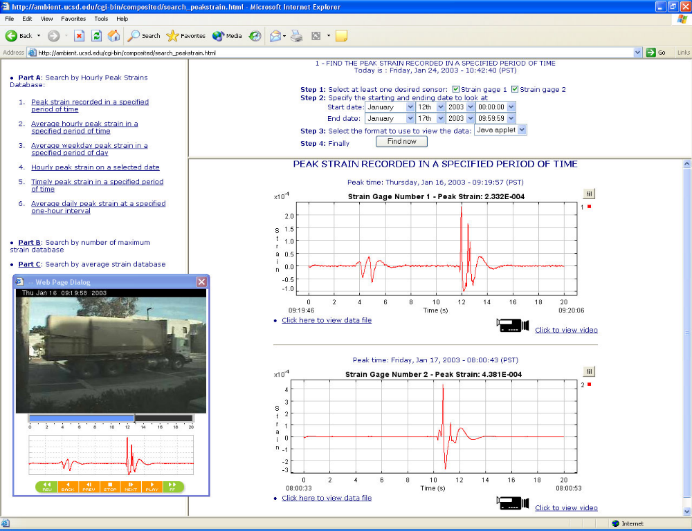

Figure 1. Pilot on-line continuous monitoring effort (http://bridge.ucsd.edu/compositedeck.html)

- Develop demonstration applications based on bridge field testbeds. This will allow researchers interested in structural health monitoring to exercise the framework using real life application examples and to contribute to enhancing the "toolkit" of methods supported by the framework. The research will make use of large bridge field testbeds made available by the California Department of Transportation (Caltrans). An example of such a testbed is the Vincent Thomas Bridge in Los Angeles. A pilot on-line continuous monitoring effort may be viewed live at http://bridge.ucsd.edu/compositedeck.html. This pilot system monitors the long-term performance of three fiber reinforced polymer (RFP) bridge-deck panels, installed in 1996 along a roadway at the University of California, San Diego (UCSD), under usual traffic loading conditions [5, 6]. This effort integrates the essential elements of an automated on-line continuous monitoring framework for bridge systems. Data from motion sensors and associated video signals are retrieved in real-time, over the Internet on a 24/7 basis (24 hours, 7 days a week) (Figure 1). Computer-based data management and analysis algorithms are currently under development.

4. RESEARCH PLAN

The overall research plan addresses development of: 1) a high-performance database with data cleansing and error checking, data curation, storage and archival, 2) networked sensor arrays, 3) computer vision applications, 4) tools of data analysis and interpretation in the light of physics-based models for real-time data from heterogeneous sensor arrays, 5) visualization allowing flexible and efficient comparison between experimental and numerical simulation data, 6) probabilistic modeling, structural reliability and risk analysis, and 7) computational decision theory. In order to satisfy these requirements, the research is making use of recent advances in (1) high-performance databases, knowledge-based integration, and advanced query processing, (2) instrumentation and wireless networking, (3) computer vision, (4) data mining, model-free and model-based advanced data analysis, and visualization. An integrated system with the conceptual architecture represented in Figure 2 is being built to achieve the above mentioned objectives. As mentioned above, the components of this system are:

- High-performance database with advanced query processing and knowledge-based integration.
- Sensor arrays and Internet networking.
- Computer vision applications.
- A suite of advanced data modeling, analysis, and visualization tools.

The above components are being interfaced via an application testbed and database integration software toolkit (software glue). This system integrates all tasks from sensor configuration, data acquisition and control to decision-making and resources allocation.

4.1 Database research
4.1.1 High-performance computational infrastructure for analysis
The complexity of data sources (including real-time sensor and video streams, and the output of physics-based and statistical models), and the need to perform advanced real-time and off-line analyses (often requiring the integration of real-time sensor data with simulation model output) necessitates a scaleable high-performance computational infrastructure.

The SDSC Data Mining facility leverages unique hardware and software resources, and database and data mining expertise, to provide advanced data analysis and data mining capabilities for scientific and engineering applications. The SDSC Data Mining group is focusing on key enabling technologies for advancing the state-of-the-art in data and knowledge management infrastructure, including (1) middleware toolkits for application and database integration, and (2) data modeling, integration and complex query processing. These technologies will be employed in the development of a high-performance data management, analysis and interpretation system for civil infrastructure monitoring. This system will integrate sensors, databases, modeling, analysis, visualization and simulation tools, and provide access to various application interfaces (e.g., reliability and risk assessment, event response) through a secure portal.

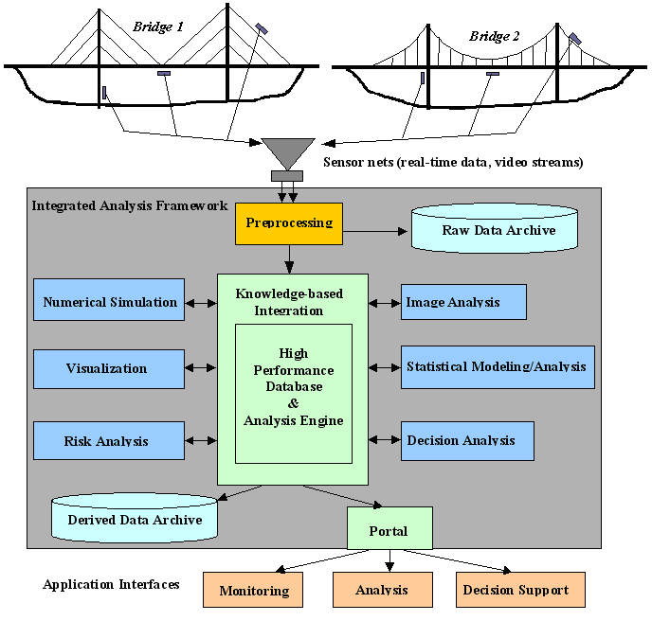

Figure 2. Conceptual System Architecture

4.1.2 Middleware toolkits for application and database integration
As depicted in Figure 3, a number of intermediate steps are needed in this process, from data collection and cleansing, analysis, visualization, to applications and decision support. Processing often takes the form of an analysis pipeline that spans multiple, possibly iterative, steps from data collection at one end to data publication, applications, and decision support at the other. This pipeline of processing steps is the knowledge discovery and data mining (KDD) pipeline and the SDSC Data Mining facility is actively engaged in creating the software infrastructure necessary to build and manage such KDD pipelines.

The KDD pipeline software that is planned includes a 3-tier Java application (client, server, and data sources and analysis and mining programs). This toolkit provides the software glue for constructing complex applications. It also provides custom tools for loading very large databases, accessing archival storage systems, and performing complex queries. It includes innovative features such as intelligent data staging, system logging of all activities, and the ability to save and replay analysis sessions. It is engineered specifically to enable large-scale analysis and decision support activities within a high-performance computational infrastructure.

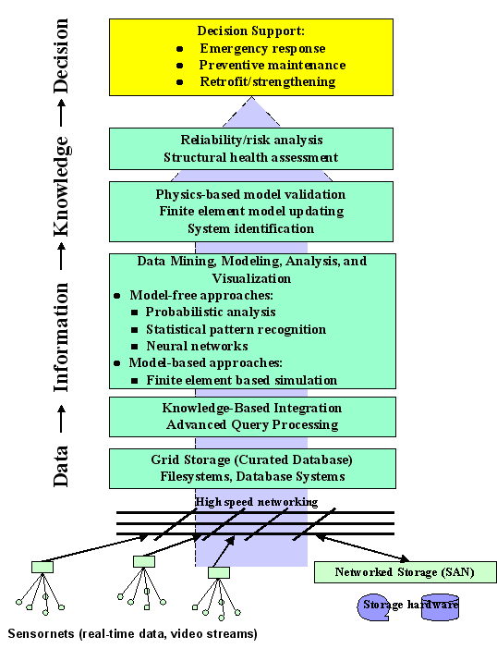

Figure 3. Knowledge Discovery Hierarchy

4.1.3 Data modeling, integration and complex query processing

A central component of the project is a data management system that stores raw and pre-processed sensor data from multiple sensor streams, video data from multiple cameras, simulated data generated from structural models, and derived data produced by a variety of analysis tools. The role of the system is to provide query support to the structure analyst who may wish to retrieve stored or computed information from a single data source, or from a virtual data source constructed by integrating multiple actual data sources. As shown in Figure 2, the data management system also interfaces with several different analysis tools and data mining software, either to export data to them, or to store back results of computations performed by these engines, producing derived data that may itself be queried.

4.1.4 Data modeling for grid-structured real-time sensors
A grid-like data structure is being developed for the database system to represent data from a variety of spatially distributed sensors (or simulation engines) from a bridge or a building. This grid-like data structure provides the equivalent of a wireframe representation of the structure and will transform the coordinate space of the structure to an (x, y, z, t)-indexed array – all sensor positions and data will be mapped against this array for querying. This enables us to use existing array data models [7, 8] and their extensions [9].

However, for the purpose of this project, we will need to extend the data representation and model functionality in several ways. For instance, the data model must support spatio-temporal aggregate queries, and spatio-temporal event queries. To accomplish this, we are developing a grid-path-expression language, which extends path expressions by attaching array indices to nodes, and to constrain paths to be only along certain dimensions (e.g., for tracking of a strain or loading wavefront). Finally, in order to compare observations, we will extend existing temporal similarity query evaluation techniques [10-12] to spatio-temporal patterns.

4.1.5 Integrating with video and load modeling software
As a novel aspect of our research, we plan to create a load database for video data. For video data, the database will record the types (e.g., an 18-wheeler vs. a compact sedan) and positions of load objects at specific time instants. This will be stored as a spatially indexed valid-time temporal data coming from the video analysis engine. It will be converted to a load by a video data wrapper process, which will consult a separate look-up table or a load generation function for each object recorded at a time instant, and, assuming that the granularity of the structure representation is finer than the pixel granularity of the video, return for each array element of the structure an estimated load at the time instant. Under the assumption above, the wrapper will have the capability to perform the reverse query, where the user selects a load condition and requests all time instants in the video where the condition is satisfied, or the query where the system consults prior data to estimate the load distribution for a user-defined traffic arrangement.

4.2 Sensor Networking
4.2.1 Integration of multiple sensor streams
A significantly new research challenge of our project is the need to integrate multiple sensor streams to develop local and global health-state indicator variables that need to be queried and monitored by the system. The indicators may be defined as user-specified aggregates (or other functions) over instantaneous values of several streams, over pre-computed aggregates covering one or more sensors. The system needs to allow a view definition mechanism over the array. For example, a fragment of the array covering a truss of a bridge could constitute a view. These views may be nested, allowing the user to specify a larger substructure on smaller structures. The participants of this project have significant prior work in the development of information integration systems [13-16]. We are extending this work to adapt the query architecture for spatio-temporal queries and similarity queries supporting the data model described in a previous section.

4.2.2 Wireless technologies
The sensor network consists of a dense network of heterogeneous sensors. In addition, the network must be easy to deploy, scalable – allowing for progressive deployment over time, and allow for local processing and filtering of data and remote data collection, access and control. Using a ubiquitous and inexpensive wireless communication technology to create Fixed Sensor Area Networks (FSANs) will accelerate the extensive deployment of sensor technology [17]. Wireless networks can be much more cost and time effective and are also easier to deploy especially in remote locations. In some application scenarios, a wireless solution can vastly reduce the monitoring installation cost, where the cabling alone generally constitutes 30-45 percent of the total cost. Ultra Wide Band (UWB) is a promising technology for sensor networks. It is well suited to short range communications, energy efficient, with high penetration capabilities. A UWB MAC suitable for ad hoc sensor networking is being considered, with two way peer to peer communication. Each sensor must be addressable, self configurable, self healing (tolerance for any unexpected link failures), and power efficient.

4.3 Computer Vision Application
4.3.1 Visualization
Visualization is often the first step in data exploration, enabling scientists and decision makers to exploit the pattern recognition capabilities of the human visual system. Visualizations of sensor measurements, features extracted from measurements, and simulation results provide visual interpretations of infrastructure status and behavior (e.g., modal strain energy distribution). Graphical displays of decision support information (e.g., critical events, error bars of estimated parameters, reliability sensitivity results, inventory of available resources) are also important in applications such as real-time disaster response and preventive maintenance.

4.3.2 Computer vision
The UCSD Computer Vision and Robotics Research (CVRR) laboratory (http://cvrr.ucsd.edu) has been developing sensing and processing capabilities related to the above tasks [18-24]. A distributed Video Networks project is already operative and is an outdoor Computer Vision Testbed on the UCSD campus (http://cvrr.ucsd.edu).

It is anticipated that computer vision will become a primary and routine sensing technique within any health monitoring framework. Broader impacts of the proposed Computer Vision research include the areas of Rescue and Crisis Management Systems, Traffic Flow Analysis and Modeling, Intelligent Transportation and Telematics Systems, and Surveillance and Security of Public Spaces. Distributed Video Networks will serve two main purposes:

- To quantitatively measure relative bridge deck motions, component motions, and differential joint-motions. In this regard, no sensors are currently available for accurate measurement of displacements along an extended structure such as a bridge (we usually rely on double integration of acceleration records, but this may introduce significant error).

- To provide quantitative information about the pattern of the traveling traffic loads (and indirectly, an idea about magnitude of these loads) by using pattern recognition/video-processing techniques. Integration of acting traffic loads (or load patterns) with the corresponding measured strains will reduce uncertainty during the system-identification analysis phase (by limiting the scope of possible causative load configuration scenarios). The association between the event and the corresponding action will be stored in an Event-Action Database (EAD) that can be manipulated through a web-based interface by an expert human operator.

4.3.3 Data Fusion
In this context, many cameras and potentially different types of video sensors are involved. For this reason, a serious and exciting investigation to systematically develop frameworks, models, and algorithms for the fusion of such different type of sensors is being undertaken. The vision system will be a fusion of the different "vision" sensors employed. The data streams produced by the video sensors will be collected and processed by central data processing facilities. Alternatives to collecting the data streams of all sensors in one central data processing facility and performing all necessary sensor management operations are: (1) to consider every sensor as a simple service provider; the central service provided is the transmission of the data stream collected by the sensor, or (2) to establish flexible and highly configurable federations of sensors by combining their services into new virtual sensors and corresponding services. From the software engineering point of view, this requires provision of a flexible, enabling software architecture for dynamically establishing and managing sensor federations [18, 19].

4.4 Damage Detection and Data Analysis Research
4.4.1Advanced Data Analysis for Structural Health Monitoring
This research includes tasks aimed at evaluating, calibrating and applying several promising approaches for detecting small structural changes or anomalies in bridge structures and quantifying their effects all the way up to decision making. These approaches include (1) use of higher-order statistics to detect changes in the system's influence coefficients, (2) use of nonparametric methods such as neural networks to detect changes in model-unknown structures, as well as on basic understanding of nonlinear mechanics by developing physics-based models that can be used for on-line identification of complex nonlinear, degrading systems (i.e., hysteretic systems), (3) use of statistical pattern recognition for structural health monitoring from vibration data, (4) integration of non-destructive damage identification methods with reliability and risk analysis methods, and (5) use of probabilistic networks and computational decision theory to integrate system uncertainties and derive rational decision policies. The above approaches are discussed briefly below.

4.4.2 Damage Detection on the Basis of Influence Coefficients
This method uses a time-domain identification procedure to detect structural changes on the basis of noise-polluted measurements. This approach requires the use of excitation and acceleration response records, to develop an equivalent multi-degree-of-freedom (MDOF) mathematical model whose order is compatible with the number of sensors used. Application of the identification procedure under discussion yields the optimum value of the elements of equivalent linear system matrices (influence coefficients). By performing the identification task before and after potential structural changes (damage) in the physical system have occurred, quantifiable changes in the identified mathematical model may be detected by analyzing the probability density functions of the identified system matrices.

This approach exploits the physics of the class of problems usually encountered in the structural dynamics field by embedding some information about the physical model structure (the form of the equations of motion) into the identification procedure, thus endeavoring to improve the sensitivity of the system identification results to small changes in the physical system parameters. Additionally, the method provides data-based measures of the degree of uncertainty of the identification results, which is crucial in ascertaining the reliability of any damage detection scheme.

4.4.3 Damage Detection Using Neural Networks
Among the structure-unknown identification approaches that have been receiving growing attention recently are neural networks. A study by Masri et al [25] has demonstrated that neural networks are a powerful tool for the identification of systems typically encountered in the structural dynamics field. In conventional identification approaches employed in the structural mechanics community, modal information or information about the model of the structure is needed to accomplish the identification and subsequent “damage” detection. Assumptions regarding the linearity or nonlinearity of the underlying physical process (structural behavior) will have drastic effects on the model selection and the accompanying identification scheme

On the other hand, not only do neural networks not require information concerning the phenomenological nature of the system being investigated, but they also have fault tolerance, which makes them a robust means for representing model-unknown systems encountered in the real world.

4.4.4 Structural Health Monitoring Using Statistical Pattern Recognition
Other promising classes of vibration-based methods for structural health monitoring are being developed and/or implemented in the integrated data analysis and interpretation platform. These methods include primarily model-based and non-model based statistical pattern recognition methods [26-28]. Statistical methods are essential in structural health monitoring recognizing the fact that there is always uncertainty present in the simulation model, the simulation input parameters, and the observed measurements. Structural health monitoring methods based on statistical pattern recognition classify the structure in various damage states based on the statistical difference between features extracted (via signal processing, parameter estimation, or some other technique) from the measured responses of the structure in the undamaged and damaged states. The key is to find and use features that are sensitive to damage. Most commonly used features in vibration-based damage identification are model-based linear features [29] such as modal frequencies, mode shapes, mode shape derivatives, modal macro-strain vectors [30-32], modal flexibility/stiffness, and load-dependent Ritz vectors [33]. These features can be applied to either linear or nonlinear response data, but are based on linear concepts. Parameters of linear (physics-based) finite element models of structures are also used as features for damage identification purposes. These parameters (e.g., spatial distribution of stiffness) are estimated using sensitivity-based finite element updating methods using measurement data [30-32, 34, 35]. A research challenge in performing this parameter updating is to propagate uncertainties from data and model into identified parameters. A promising model-based damage identification method consists of updating (e.g., Bayesian) the parameters of a physics-based nonlinear finite element model of the monitored structure using response measurement and possibly input data. Propagation of uncertainties from data and model into the estimated parameters is a very challenging task for nonlinear finite element models. This task will be the object of significant research in this project.

4.4.5 Reliability and Risk Analysis
The model updating methodology based on a nonlinear physics-based model of the monitored structure will be used not only as a tool for tracking the health of the structure, but also as a basis to assess the reliability of the structure in performing as expected under uncertain current and future loads. The reliability of the structure against various potential limit-states can be evaluated using the probabilistic mechanics-based model of the structure (derived from statistical model updating using real output and possibly input data) and a probabilistic representation of current and future load effects and deterioration effects. Efficient reliability analysis methods will also be integrated in this framework. The combination of probabilistic non-destructive structural health monitoring techniques and computational methods of reliability analysis provides a powerful tool to continuously monitor the reliability or safety of the bridge structure under consideration [36]. This reliability analysis module then feeds into support tools for rational decision making and optimum allocation of limited resources (e.g., rehabilitation or preventive maintenance of the bridge).

4.4.6 Probabilistic Modeling and Computational Decision Theory

In view of the above discussion on probabilistic issues and their significant impact on structural health monitoring strategies, the topic of probabilistic modeling and uncertainty propagation are being thoroughly investigated in this project. Probabilistic networks (or Bayesian probabilistic networks) provide a comprehensive framework for modeling and analyzing uncertainties [37, 38]. Probabilistic nets also support approximate inference and anytime algorithms (through Monte Carlo simulation), satisfying the flexible temporal constraints imposed by real-time decision support applications, such as cases of sudden severe load conditions (e.g., natural hazards, man-made disasters, acts of terrorism). Although there have been numerous developments in this field, there are still a number of challenges in extending the theory and tools to address a larger range of applications, including incorporating background knowledge into the model-building process, inducing model structures that contain hidden variables, providing large-scale database support for probabilistic modeling and decision support, and relating probabilistic modeling with other mathematical and statistical methods (e.g., using probabilistic nets to model parameter uncertainty in physics-based models). Computational tools and modeling infrastructure for creating and manipulating probabilistic nets are currently under construction in the SDSC Data Mining Group. We will extend this activity to develop custom algorithms and tools for the application of probabilistic networks and influence diagrams to problems in civil infrastructure monitoring, analysis, and decision support.

4.4.7 Physics-based Modeling and Simulation
The computational engine for mechanics-based modeling and analysis of bridge systems will consist of OpenSees [39]. OpenSees (Open System for Earthquake Engineering Simulation) is an open source software framework to simulate the response of structural and geotechnical systems to earthquake and dynamic loads in general. OpenSees is under continual development sponsored by the Pacific Earthquake Engineering Research Center (PEER) through the National Science Foundation engineering and education centers program. The object-oriented framework of OpenSees allows the structural response simulation to be factorized into independent classes such as model building, finite elements, constitutive material models, boundary conditions and constraints, solution strategies, equation solvers, time integration algorithms, and recorders emulating sensors. OpenSees supports a wide range of simulation models, solution procedures, and distributed computing models [39]. It also has very attractive capabilities for physical parameterization of a structural model, probabilistic modeling, response sensitivity analysis and reliability analysis.

5. INTEGRATION OF RESEARCH AND EDUCATION

The Structural Engineering Department at UCSD is currently planning to develop a new inter-disciplinary Structural Engineering - Computer Science focus area in the graduate and possibly the undergraduate program. The proposed research will be a natural center of attraction and ideal training ground for the graduate and undergraduate students with interest in this new inter-disciplinary focus area.

Summary and Conclusions

This IT-based integrated analysis framework will foster the development of practicable structural health monitoring methodologies as well as the discovery of new physical knowledge in the area of deterioration (sudden or progressive) of civil infrastructure systems. The research results will not only offer an extensive list of research topics worthy of further investigation by current and future PhD students in many diverse fields of science and engineering, but it will also be of major benefit to practicing engineers planning to implement the new concept of performance-based structural design in the context of new or retrofitted civil structures incorporating elements of the emerging field of Structural Control.
The experimental studies being carried out will furnish a new structural health monitoring methodology to augment conventional approaches, thereby improving the reliability of structural damage detection and condition assessment methods, and eventually culminating in the deployment of reliable structural health monitoring instrumentation networks. The technical tasks will advance the frontiers of nonlinear system identification and modeling, thus facilitating the development of robust approaches for quantification and reduction of risk in urban seismic disasters through the use of structural health monitoring methods, non-destructive evaluation techniques, and structural control approaches.
Not only will this research lead to a powerful integrated framework for handling present and future hardware and software developments in the general field of condition assessment and damage detection under operating conditions, but it will also be of tremendous benefit in providing rapid response (in virtually real time) in assessing the condition of infrastructure systems subjected to dynamic loads caused by accidents or terrorist acts, when available manpower resources will be severely limited to perform the needed damage survey tasks by tedious, manual means.

References

1. Stalling, J. M., et al. 2000. Field performance of FRP bridge repair. ASCE, Journal of Bridge Engineering, 5/2, 107-113.

2. Aktan, E., Chase, S., Inman, D., and Pines, D. Monitoring and Managing the Health of Infrastructure Systems. Proceedings of the
2001 SPIE Conference on Health Monitoring of Highway Transportation Infrastructure, SPIE, March 6-8, 2001.

3. Necati Catbas, Korhan Ciloglu, Arda Celebioglu, John Popovics, Emin Aktan. Fleet Health Monitoring of Large Populations:
Aged Concrete T-Beam Bridges in Pennsylvania. 6th Annual Int'l Symposium on NDE for Health Monitoring and Diagnostics,
SPIE, Newport Beach, CA USA, March 4-8, 2001.

4. ISIS Canada. 2000. Strengthening reinforced concrete structures with externally bonded fibre reinforced polymers. ISIS
Canada Design Manual, Spring, University of Manitoba, Winnipeg, Manitoba, Canada.

5. Zhao, L. Characterization of deck-to-girder connections in FRP composite superstructures [thesis]. La Jolla, California:
University of California, San Diego; 1999.

6. Elgamal, A., Seible, F., Vernon, F., Trivedi, M., and Fraser, M. On-Line Structural Monitoring and Data Management. Caltrans
Report; 2001.

7. Libkin, L., Machlin, R., and Wong, L. 1996. A query language for multidimensional arrays: Design, implementation, and
optimization techniques”. In Proceedings of ACM SIGMOD, 228–239.

8. Marathe, A. P., and Salem, K. 1997. A Language for Manipulating Arrays. In Proceedings of VLDB Conference.46-55.

9. Santini, S., and Gupta, A. 2001. A data model for querying wavelet features in image databases. In Intl. Workshop on
Multimedia Information Systems, Capri, Italy, November.

10. Faloutsos, C., Ranganathan, M., and Manolopoulos, Y. 1994. Fast subsequence matching in time-series databases. In Proc.
ACM SIGMOD Int. Conf. on Management of Data, pages 419-429, Minneapolis, May.

11. Das, G., Gunopulos, D., and Mannila, H. 1997. Finding similar time series. In Proceedings of The Fourth International
Conference on Knowledge Discovery and Data Mining, August.

12. Rafiei, D., and Mendelzon, A. 1997. Similarity-based queries for time series data. Proceedings of the ACMSIGMOD
Conference on Management of Data.

13. Baru, C., Gupta, A., Ludäscher, B., Marciano, R., Papakonstantinou, Y., Velikhov, P., and Chu, V. 1999. XML-based
information mediation with MIX. Proc. of the ACM SIGMOD'99 , Philadelphia, Pennsylvania, USA, 597-599.

14. Gupta, A., Marciano, R., Zaslavsky, I., and Baru, C. Integrating GIS and imagery through XML-based information
mediation. 1999. Proc. NSF International Workshop on Integrated Spatial Databases: Digital Images and GIS, Portland,
Maine, June 1999 (Lecture Notes in Computer Science, 1737, Springer-Verlag, 211-234.

15. Zaslavsky, I., Gupta, A., and Marciano, R. 2000. Combined query and transformation planning in spatial mediators. Int.
Conf. Spatial Data Handling.

16. Ludäscher, B., Gupta, A., and Martone, M. E. 2001. Model-based mediation with domain maps, 17th Intl. Conference on
Data Engineering (ICDE), Heidelberg, Germany, IEEE Computer Society.

17. Vipin, M., and El Zarki, M. 2002. Fixed Sensor Networks for Civil Infrastructure Monitoring – An Initial Study. First Annual
Mediterranean Ad Hoc Networking Workshop, Med-hoc-Net 2002, sponsored by IFIP, Sardegna, Italy, Sept 4-6, 2002.

18. Trivedi, M., Mikic, I., and Bhonsle, S. 2000a. Active Camera Networks and Semantic Event Databases for Intelligent
Environments, IEEE Workshop on Human Modeling, Analysis and Synthesis (in conjunction with CVPR), Hilton Head,
South Carolina, June.

19. Trivedi, M. M., Mikic, I., and Kogut, G. 2000b. Distributed Video Networks for Incident Detection and Management, IEEE
Conference on Intelligent Transportation Systems, Dearborn, Michigan, October.

20. Mikic, I., Cosman, P., Kogut, G., and Trivedi, M. 2000. Moving Shadow and Object Detection in Traffic Scenes,
International Conference on Pattern Recognition, Barcelona, Spain, September 3-8.

21. Iwamoto, S., Checkley, D. M., Jr., Trivedi, M. M., 2001. REFLICS: Real-time flow imaging and classification system,
Machine Vision and Applications, 13, 1, 1-13.

22. Kogut, G. and Trivedi, M.M. 2001. Maintaining the identity of multiple vehicles as they travel through a video network,
Proceedings of IEEE Intelligent Transportation Systems Conference (ITSC), pp. 758-763, Aug.

23. Hall, A., Huang, K., and Trivedi, M., 2001. A Televiewing System for Multiple Simultaneous Customized Perspectives and
Resolutions, Proceedings IEEE Intelligent Transportation Systems, pp. 657-662, Aug.

24. Ng, K. C., Trivedi, M. M., and Ishiguro, H. 2001. Range-Space Approach for Generalized Multiple Baseline Stereo and
Direct Virtual View Synthesis, Int. Journal of Computer Vision, Special Issue on Multicamera Stereo (in press).

25. Masri, S.F., Chassiakos, A.G., and T.K. Caughey. 1993. Identification of nonlinear dynamic systems using neural networks.
Journal of Applied Mechanics, Trans. ASME, Vol. 60, March, 123-133.

26. Stubbs, N. and Garcia, G. 1996. Application of pattern recognition to damage localization. Microcomputers in Civil
Engineering, 11, 395-409.

27. Farrar, C. R., Duffey, T. A., Doebling, S. W., and Nix, D. A. 1999. A statistical pattern recognition paradigm for vibration-
based structural health monitoring. Structural Health Monitoring 2000, 764-773.

28. Lopez, F. P., and Zimmerman, D. C. 1999. A pattern recognition approach for damage localization using incomplete
measurements. Proc. 17th Int. Modal Analysis Conf., 579-85.

29. Doebling, S. W., Farrar, C. R., and Prime, M. B. 1998. A summary review of vibration-based identification methods. Shock
and Vibration Digest, 205/5, 631-645.

30. Cheeseman, P.; Self, M.; Kelly, J.; Taylor, W.; Freeman, D.; and Stutz, J. 1988. Bayesian classification. In Proceedings of
the Seventh National Conference on Artificial Intelligence, San Mateo, CA:Morgan Kaufmann 607-611.

31. Conte, J. P., Liu, M., and Inaudi, D. 2000. Earthquake response monitoring and damage identification of structures using
long-gage fiber optic sensors. Proc. of the 14th ASCE Engineering Mechanics Conference, The University of Texas, Austin,
Texas.

32. Conte, J. P., and Liu, M. 2001. Use of long-gage fiber optic sensors for earthquake response monitoring and non-destructive
evaluation of structures. CUREE Publication No. CKIII-04, CUREE-Kajima Joint Research Program - Phas III.

33. Sohn, H., and Law, K. H. 2000. Application of load-dependent Ritz vectors to Bayesian probabilistic damage detection.
Probabilistic Engineering Mechanics, 15, 139-153.

34. Mottershead, J. E., and Friswell, M. I., 1993. Model updating in structural dynamics: a survey. Journal of Sound and
Vibration, 162/2, 347-375.

35. Hemez, F. M., and Farhat, C. 1995. Structural damage detection via a finite element model updating methodology. SEM
International Journal of Analytical and Experimental Modal Analysis, 10/3, July, 152-166.

36. Stubbs, N., Park, S., Sikorsky, C., and Choi, S. 1998. A methodology to nondestructively evaluate the safety of offshore
platforms. Proc. of the 18th Int. Offshore and Polar Engineerring Conf., Montreal, Canada, May 24-28.

37. Pearl J. 1988. Probabilistic reasoning in Intelligent Systems: networks of plausible inference. Morgan Kaufmann.

38. Charniak, E. 1991. Bayesian networks without tears. AI Magazine, Menlo Park, CA:AAAI Press 12(4):50-63.

39. McKenna, F., and Fenves, G. L. 2000. An object-oriented software design for parallel structural analysis. Proc. of the
SEI/ASCE Structures Congress, Philadelphia, PA, (http://opensees.berkeley.edu).

* elgamal@ucsd.edu; phone 1 858 822-1075; fax 1 858 822-2260

